**Holiday Booking System for Straight Walls Ltd**

**Prepared for Dr. Markus Wolf**

**By University of Greenwich Student Team:**

**Anastassiya Tikhonova**

**Armando Koldashi**

**Beniamin Jitca**

**Cem Ekin Sunal**

**Isidor Papajani**

**Miglena Angelova**

**February 2020**

# Executive Summary

## Overview of work sequence

This report was compiled for Dr Markus Wolf a course leader at University of Greenwich by a student group in the University of Greenwich.

|  |  |
| --- | --- |
| **Summary Information** | |
| **Report prepared by a student team for** | Dr Markus Wolf |
| **Work flow processed at** | University of Greenwich |
| **Duration of work flow** | 16/01/2020 – 26/02/2020 |
| **Course** | Programming Enterprise Components |

## Form of report

This report serves as the solution design for the system implemented for Straight Walls Ltd company. It references all the presented and supplied work required to implement the system in part A from the document of the COMP1610(2019/20) Course work. The report references other artefacts such as the code, which is included on the supplied zip files.

# Contents

Table of contents

Executive Summary 2

1.1 Overview of work sequence 2

1.2 Form of report 2

Contents 3

**1** **Introduction** 4

1.1 Overview 4

1.2 Aims/Objectives 4

**2** **Roles in the team** 4

**3** **Group Report Deliverables** 5

3.1 Entity Relationship Diagram 5

3.2 Architecture Diagram 6

**4** **Individual Report Deliverables** 7

**5** **Conclusions** 7

Figures

Figure 1: Entity relationship diagram for Booking Holiday System 5

Figure 2: Architecture Diagram for Booking Holiday System 6

# **Introduction**

## Overview

This report describes the work that was done from the 16th of January till the 26th of February 2020 to architect and implement a holiday booking system solution.

## Aims/Objectives

The presented student group of the University of Greenwich has been employed by Straight Walls Ltd company to propose a new, integrated holiday booking software system. The client Markus Wolf has specified some of the main objectives of the project and information on the targets was supplied by a document uploaded on the Moodle University Page. This project had three requirements objectives: 1) Design/implement a database which meets the requirements of the case study; 2) Set up an Application Server which will allow you to deploy an enterprise application; 3) Implement a web application using Jakarta EE, which offers Admin User log in and Admin User management functionality.

The deliverables for part A aimed to produce:

1. A group report with:

* An entity relationship diagram which represented the conceptual data model of the “Booking Holiday” system;
* An architecture diagram which shows the overall setup of the system.

1. An individual report section which include a reflection of the individual roles within the team and discuss lessons learnt;
2. A prototype of the “Holiday Booking” system demonstration.

# **Roles in the team**

The following roles have been identified in the team:

|  |  |  |
| --- | --- | --- |
| **Roles in the project** | | |
| **Company** | Straight Walls Ltd | |
| **Client** | Markus Wolf | |
| **Development Team** | Project Manager: Armando Koldashi  Database administrator/ User interface: Anastassiya Tikhonova  Java back-end programmer: Beniamin Jitca  Java back-end programmer/ User interface: Cem Ekin Sunal  Database design: Isidor Papajani  Database design: Miglena Angelova | |
|  | |  |

# **Group Report Deliverables**

## Entity Relationship Diagram

An entity relationship diagram (ERD) shows the relationships of entity sets stored in a database. By defining the entities, their attributes, and showing the relationships between them, an ER diagram illustrates the logical structure of databases. The used ERD in the designed product is shown on Figure 1.

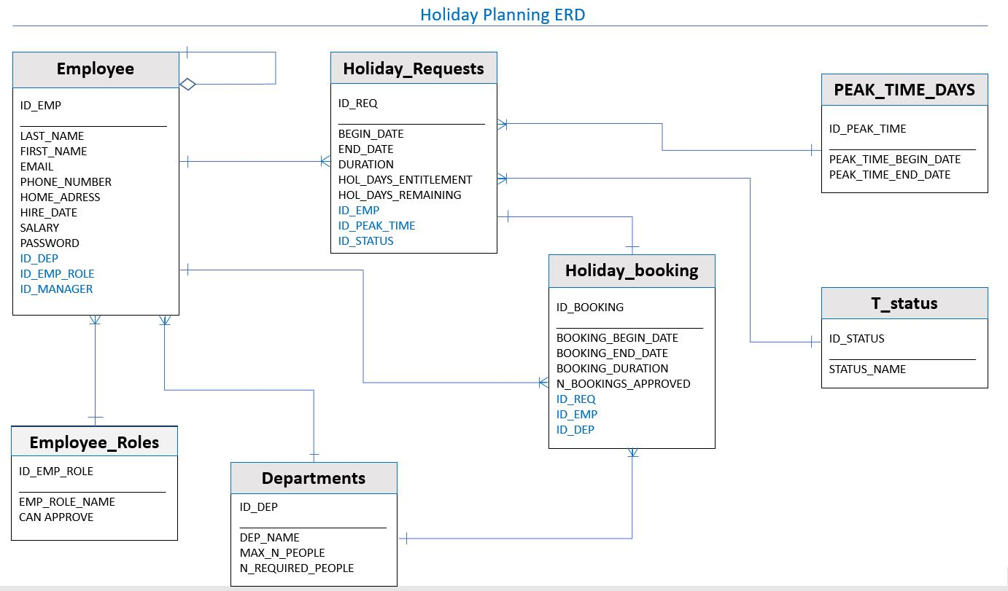

Figure 1: Entity relationship diagram for Booking Holiday System

## Architecture Diagram

An architecture diagram was designed to visualize the graphical representation of a set of concepts, architecture principles, elements and components, which were used in the process of designing the Holiday Booking System. Figure 2 demonstrates this diagram.

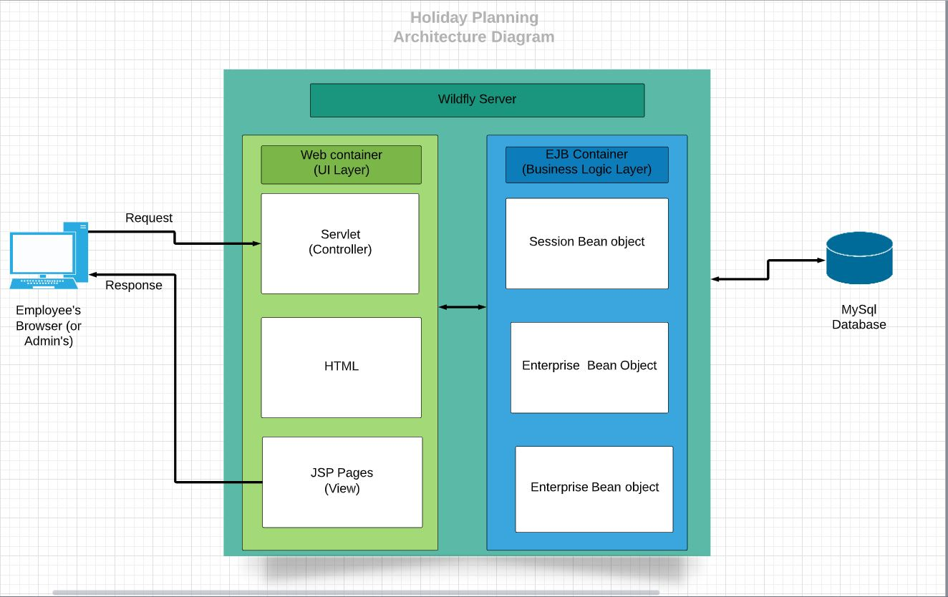

Figure 2: Architecture Diagram for Booking Holiday System

# **Individual Report Deliverables**

I advised and provide feedback for the construction of the database and the architecture of the web application. For the begin, I started with the configurations for the database but I have some issues with the connection for MySQL and the connector on the WildFly, but those were solved by my team-mate Cem. The most contribution from my side for this project was the implementation at the server level, the adding and the update functionality for the employee part. The challenging part was to connect the jsp form with the servlet and to understand the structure and how to distribute the functionality in small pieces, like using a pattern for a good code structure, also to import external files in order to use essential things like JPA, but the most challenging task was the connection with the database, the issues raised by the latest version of the WildFly 18.0 and the connector and some missing configurations, this was a test for dealing with unknowing and unpredicted problems that most of the time are regarding the configuration phase from a project.

# **Conclusions**

The main objectives of this part A of the project were achieved. The aim of the course was to introduce the students to modern Jakarta EE enterprise components and to help them develop skills which will be necessary for producing a software system. A good refresh of some techniques and new knowledge are the outcomes of this module. All of the weekly tasks and the tutor’s feedbacks have built a solid and essential background knowledge for the success of future software designing works.